PSD97_Deal_Initial load clearance program Specification & Unit Test Plan

|  |
| --- |
|  |

16/11/2015

#### Document information

|  |  |  |
| --- | --- | --- |
| Document owner | Ganesh Verma | |
| PowerSteering code | Not Applicable | |
| Prepared by | Ranjith Gopalankutty | |
| Contact details | Ranjith.Gopalankutty[@Boots.co.uk](mailto:bibin.bhanu@boots.co.uk) | |
| Document classification  (indicate with a X in the right hand column) | Key Project Document | X |
| Supporting Project Document |  |
| Process Document |  |
| Operating Procedure |  |
| Quality Standard |  |
| Document location and filename | <https://boots1.sharepoint.com/sites/ITService/AppsManagement/RetailIntegration/EPOS/Application%20Documentation> | |
| Version number | 1.0 | |
| Document status | Final | |

Document history

| **Version no.** | **Date** | **Change** |
| --- | --- | --- |
| 1.0 | 16/11/2015 | Final Version |
|  |  |  |
|  |  |  |

Reviewer/Authorisation

| **Name** | **Title** | **Responsibilities** | **Authorisation Signature** |
| --- | --- | --- | --- |
| Ranjith Gopalankutty | **Technical Analyst** | Internal Reviewer |  |
| David Artiss | **Senior Technical Analyst** | Reviewer/Authoriser |  |
| Ganesh Verma | **Service Manager, Retail Application Management** | Reviewer/Authoriser |  |
| Jamie Thorpe | **Solution Design** | Reviewer/Authoriser |  |
| Paul Bowers | **Manager Solution Design** | Reviewer/Authoriser |  |

Distribution

| **Name** | **Title** |
| --- | --- |
| Emma Whitby | **Project Co-ordinator** |
| Anne Greener | **Test Manager** |

Related documents (if any)

| **Document name** | **Location** |
| --- | --- |
|  |  |

Contents

Document information 1

Document history 1

Reviewer/Authorisation 2

Distribution 2

Related documents (if any) 2

1. Preface 4

1.1 Document Purpose 4

1.2 Scope of document 4

2. Overview 4

2.1 Executive Summary. 4

2.2 Requirements Matrix 4

3. Specification 5

3.1 Overview 5

3.2 Detail 5

3.3 Error Reporting 10

3.4 Handover 11

3.5 Archive 12

4. Unit Test Plan 14

4.1 Overview 14

4.2 Unit Test Scripts 14

1. Preface
   1. Document Purpose

The purpose of this document to describe the design and testing plan for new screen based BCF clearance program. Currently Pricing and deals team sends the ticket to Epos AppsMgmt queue to get the serial numbers reset. With this screen based utility, they will be able to run it their own.

* 1. Scope of document

This document will detail the details and testing plan for the new screen based BCF clearance program PSD97.286. It will not change any existing applications for it. This will detail to the changes to existing file MOAT.BIN, DMOAT.DAT.

1. Overview
   1. Executive Summary.

Whenever a store has deals issue instead of running DELOK suite, Deal initial load will be tried, So that no data corruption happens by repeated running of deal related program. It is achieved by running a bat program called DEALBCF0.BAT and DEALBCF1.BAT. Which is a command line based program. As pricing and deals team can’t do this, ticket will be passed to AppsMgmt queue. In order to simplify the process and make it more intuitive, it was decided to add a more intuitive screen based program to exiting menu option. New menu will sit in 1-4-2-7. And will be accessible to users only with id 99999999. For rest of the users, menu option will be hidden.

* 1. Requirements Matrix

| **Number** | **Requirement** | **Solution Reference** |
| --- | --- | --- |
| 1 | Create a screen based program for BCF clearance. | 3.2.1 |
| 2 | The menu option should only be visible to users signed in with 99999999 | 3.2.2 |

1. Specification
   1. Overview

The look and feel of the new program will be on par with Boots standards. Menu will be residing under option 1-4-2-7. It can be accessed to users only with user id 99999999.

* 1. Detail

Program will be serving 2 functions, once the screen is opened, it will help the users to know the serial numbers of deal related files in the BCF, also during initial load process users can decide and reset the BCF serial numbers if required.

1. **A new screen program for BCF Clearance.**

New program will be under the menu option 1-4-2 and option 7. Initially it was decided that, it will go under menu option 1-4-2-1 and as 9th menu options. But the screen has already 8 menus and PSB50 and MOAT does not support 9th one. By doing so, one could get spurious result, so it was moved to exiting menu option.

MAIN.SCREEN:

WHILE NOT EXIT.NOW

CALL DM.SHOW.SCREEN(1, "", 2, 2)

! Reads BCF and get the current serial numbers of various deal

! related files and display on the screen. If the current

! values are already zero, user can refrain from running the

! program

GOSUB BCF.OPEN

GOSUB BCF.READ

GOSUB BCF.CURRENT.FIELD

GOSUB CLOSE.PROCESSING

When the user pressed Y key below code will execute

IF UCASE$(FIELD$(3)) = CHR$(89) THEN BEGIN

CALL DM.STATUS ("MESSAGE(251,'')")

WAIT ;500

! Opens BCF file and reads 14th record, after getting

! the DIDIR,DVCHR AND DEALDIR serial number it sets

! the flag accordingly. If the values are already

! zero then RESET and INITIALIZED flag will set and

! message B186 will be shown on the screen

GOSUB BCF.OPEN

GOSUB BCF.READ

GOSUB VALIDATE.BCF

GOSUB CLOSE.PROCESSING

IF RESET = TRUE THEN BEGIN

INITIALIZED = TRUE

ENDIF ELSE BEGIN

! If serial numbers are not set to zero then main processing

! subroutine will be called and the values will be set to zero

GOSUB BCF.OPEN.LOCKED ! For writing

GOSUB MAIN.PROCESSING

CALL DM.STATUS ("MESSAGE(299,'')")

GOSUB BCF.CURRENT.FIELD

Checking for the current value in the file to decide on reset

VALIDATE.BCF:

IF BCF.DEALDIR.SERIAL.NUM$ = "0000" AND \

BCF.DIDIR.SERIAL.NUM$ = "0000" AND \

BCF.DVCHR.SERIAL.NUM$ = "0000" THEN BEGIN

RESET = TRUE

ENDIF

RETURN

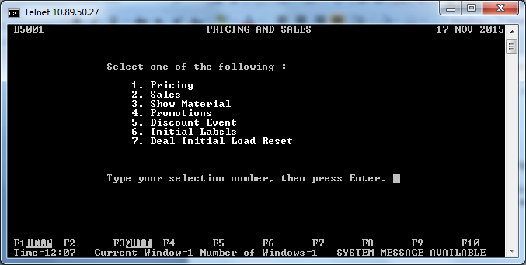

By choosing the menu option 7 and pressing enter below screen will be opened

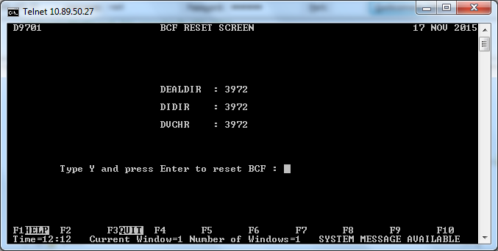

From the above screen, user can decide if they want to run the program, for any letter other than Y below error will be popped

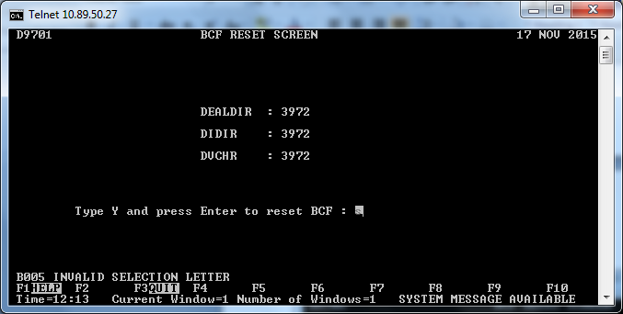

After giving the right letter and pressing enter key program w ill reset the deal related serial numbers to ‘0000’ as like below

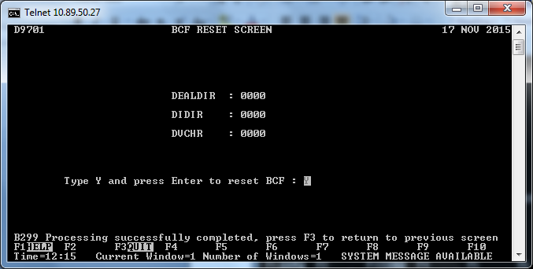

If the user tries to run the option again error message b186 will be thrown

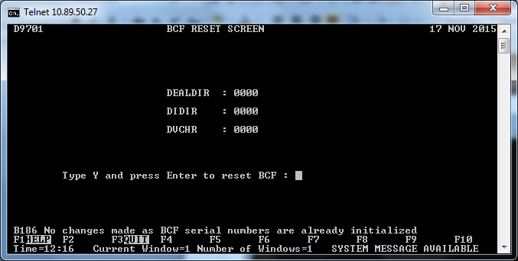

Help screen can be accessed using F1 key and will guide through user on the usage of the screen

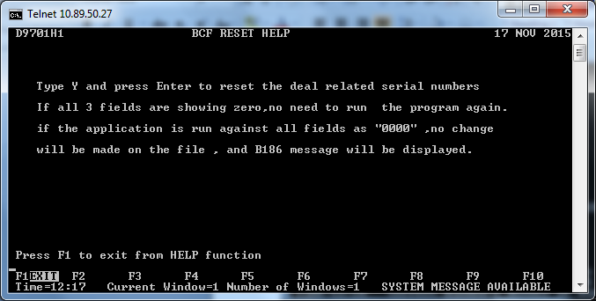

1. **The menu option should only be visible to users signed in with 99999999.**

Menu will be visible only for users with id 99999999; it’s for preventing the mis usage of the menu as well accidental reset of BCF by store users.

Same will be achieved using DMOAT settings as below

**"27. Deal Initial Load Reset --------,Y-------PSD97 "**

Which will prevent unauthorized access of the same and the menu will be low lighted for other users, as like below

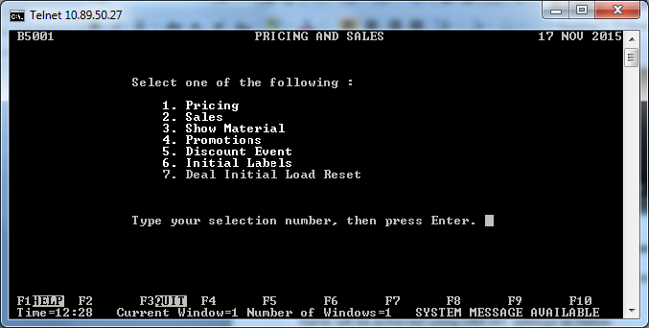

When any user with other than **99999999** tries to access it below error will be displayed

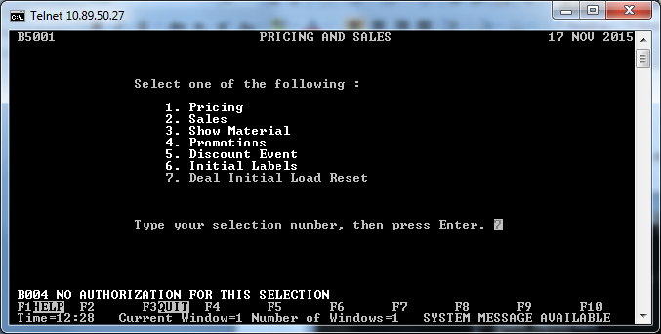

* 1. Error Reporting

Error reporting will be done using below sub routines.

ERROR.DETECTED:

IF ERR = "NP" THEN BEGIN ! Command mode run

COMMAND.MODE = TRUE ! Command mode is set to TRUE

RESUME PROGRAM.CONTROL

ENDIF

GOSUB FILE.ERROR

FILE.ERROR:

EVENT.NO% = 106

FILE.NO$ = CHR$(SHIFT(BCF.REPORT.NUM%,8)) + \

CHR$(SHIFT(BCF.REPORT.NUM%,0))

IF FILE.OPERATION$ = "O" THEN BEGIN ! Open error

MESSAGE.NO% = 501 ! Message No. for open error

ENDIF ELSE IF FILE.OPERATION$ = "R" THEN BEGIN ! Read error

MESSAGE.NO% = 508 ! Message No. for Read error

ENDIF ELSE IF FILE.OPERATION$ = "W" THEN BEGIN ! Read error

MESSAGE.NO% = 504 ! Message No. for Write error

ENDIF

VAR.STRING.1$ = FILE.OPERATION$ + \

CHR$(SHIFT(BCF.REPORT.NUM%, 8) AND 0FFH) + \

CHR$(BCF.REPORT.NUM% AND 0FFH) + \

CURRENT.CODE$

VAR.STRING.2$ = RIGHT$("000" + STR$(BCF.REPORT.NUM%),3) + \

UNPACK$(CURRENT.CODE$)

RC% = APPLICATION.LOG (MESSAGE.NO%, VAR.STRING.1$, \

VAR.STRING.2$,EVENT.NO%)

GOTO ESCAPE.PRESSED

File will be initially opened with read access only to get the data and display. This will help to avoid the file lock errors. When the user tries to reset with valid Y letter, File will be reopened in locked mode.

* 1. Handover
     1. Handover File Detail

| **Name** | **Description** | **Size (on 4690)** | **Version (Dimensions)** |
| --- | --- | --- | --- |
| PSD97.286 | Controller book in application | 127312 |  |
| PSDD97.DAT | Display File | 1152 |  |
| PSDH97.DAT | Display Help file | 1280 |  |
| MOAT.BIN | Menu file (Direct format) | 61952 |  |
| DMOAT.BIN | Menu sequential file | 14433 |  |
| PSD97.BAS | Source File | 23631 |  |
| PSD97.INP | Input file |  |  |
| PSD97.OBJ | Object File | 9878 |  |
| PSD97.LST | List file | 108533 |  |
| PROGRAMS.DOC | Updated program names |  |  |

* + 1. QA/Support Files Updated - Checklist

| **Description** | **Name** | **Updated** |
| --- | --- | --- |
| **Report file numbers used in error reporting** | REPORT.TXT & REPORT.NUM | ❑Yes 🗹 No |
| List of Pipe usage | PIPES.TXT | ❑Yes 🗹 No |
| **Event numbers used in error reporting** | EVENT.TXT | ❑Yes 🗹 No |
| **List of Programs and description** | PROGRAMS.DOC | 🗹Yes 🞎No |

* 1. Archive
     1. Archive File Details

| **File Name** | **Description** | Change | **Distribution Type** | **Size (on 4690)** | **Version (Dimensions)** |
| --- | --- | --- | --- | --- | --- |
| PSD97.286 | Executable |  | 5 | 127312 |  |
| PSDD97.DAT | Display help file |  | 5 | 1152 |  |
| PSDH97.DAT | Display File |  | 5 | 1280 |  |
| MOAT.BIN | Display menu |  | 3 | 61952 |  |
| DMOAT.BIN | List File |  |  | 14433 |  |
| PSD97.BAS | Reference file |  | 5 | 23631 |  |
| PSD97.INP | INP file |  |  |  |  |
| PSD97.OBJ | Object File |  | 5 | 9878 |  |
| PSD97.LST | List file |  |  | 108533 |  |
| PSD97.XRF |  |  |  |  |  |

1. Unit Test Plan
   1. Overview

* Ensure the Controller is running a 15B Build.
* Please make sure controller has BCF.BIN
* Please place new DMOAT.BIN in D:/ADX_UDT1 directory
  1. Unit Test Scripts

|  |  |  |  |  |  |
| --- | --- | --- | --- | --- | --- |
| **Test No.** | **Test Description** | **Expected Result** | **Pass/Fail** | **Actual Result if Fail** | **Problem No. on Database** |
| 1 | Step 1:  Place PSD97.286,PSDD97.DAT and PSDH97.DAT in c:/adx_upgm  Step 2:  Place DMOAT.BIN in D:/ADX_UDT1  Step 3:  Run MAKEMOAT.286 from CUPGM  Step 4:  Make sure the program completes fine  Step 5:  Try accessing the menu option 1-4-2-7 | Make sure all the menus option are present before and new option 7 is visible as like below | Pass |  |  |
| 2 | Step 1:  Navigate to 1-4-2-7 and press enter  Step 2:  Make sure the screen load fine | Screen D9701 should loads fine with all the fields | Pass |  |  |
| 3 | Step 1:  Navigate to 1-4-2-7 and press enter  Step 2:  Make sure the screen loads fine with the existing values in BCF  Step 3:  Type S and press enter key | “B005 Invalid selection letter should be displayed on screen” | Pass |  |  |
| 4 | Step 1:  Navigate to 1-4-2-7 and press enter  Step 2:  Make sure the screen loads fine with the existing values in BCF  Step 3:  If the existing values are 0000 in all 3 fields type y and press enter | “B186 No changes made as BCF serial numbers are already initialized” on screen | Pass |  |  |
| 5 | Step 1:  Navigate to 1-4-2-7 and press enter  Step 2:  Make sure the screen loads fine with the existing values in BCF  Step 3:  If the values are non zero type Y key and press enter  Step 4:  B251 message will be displayed momentarily and reset will happen  Step 5:  Manually DREDIX BCF.BIN and verify record 14.  Step 6:  First 8 digit and last 4 digit of the record should be zero | “B299 Processing successfully completed , press F3 to return to previous screen” will be displayed | Pass |  |  |
| 6 | Step 1:  Navigate to 1-4-2-7 and press enter  Step 2:  Make sure the screen loads fine with the existing values in BCF  Step 3:  Press F3 key | Screen should come back to previous screen | pass |  |  |
| 7 | Step 1:  Navigate to 1-4-2-7 and press enter  Step 2:  Make sure the screen loads fine with the existing values in BCF  Step 3:  Press Escape Key | Screen should come back to PSB50 screen | Pass |  |  |
| 8 | Step 1:  Rename BCF.BIN out of the way  Step 2:  Navigate to 1-4-2-7 and press enter | Screen should load with B501 error on the message field | Pass |  |  |
| 9 | Step 1:  Navigate to 1-4-2-7 and press enter  Step 2:  Make sure the screen loads fine with the existing values in BCF  Step 3:  Press F1 key  Step 4:  Press F1 again it should load the D9701 again fine | Help screen should be loaded fine like below | Pass |  |  |
| 10 | Step 1:  Navigate some random menus and try few functionalities  Step 2:  All of them should load and work fine like previously | New program and change should not alter anything in existing controller menus | Pass |  |  |